Art 8/9 CTF

Alberta Education has outlined 14 competency focused learning outcomes for CTF courses as listed below (which has been pulled directly from the Alberta Education website).
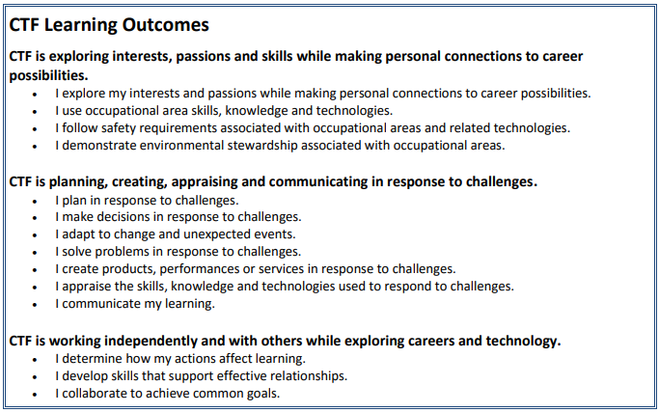

The aim for Art 8/9 CTF is to hit on the following competencies:
- I explore my interests and passions while making personal connections to career possibilities.
- I use occupational area skills, knowledge and technologies.
- I plan in response to challenges.
- I make decisions in response to challenges.
- I adapt to change and unexpected events.
- I solve problems in response to challenges.
- I create products, performances or services in response to challenges.
Art 8/9 CTF will be an exploration of various styles and some artistic techniques. The goal is to find creative projects that inspire you and allow you to express yourself while doing your best to incorporate techniques or inspiration discussed in class. There’s is no upper or lower limit to the number of projects to be completed, but there are 10 concepts we will cover that will be assessed throughout your works. Once again; formal projects will not be assigned, but if you are struggling to incorporate techniques/styles/concepts in your projects I will help you find ones that meet the objectives.

Below is a list of styles & techniques that will be discussed in class:
- Modern Art
- Colour Theory
- Dimensionality
- Line and Shape
- Re-creation
- Stippling/Hatching/Cross-Hatching
- Sculpture
- Exploration of Mediums
- Artistic careers
- Art History

Class Expectations
- Be working on a self-selected or assigned project
- Incorporate each of the concepts discussed in at least one piece of work
- Clean up after yourself
- Keep the volume down
- Run all projects by me and show me final works
- Be creative, art is about self-expression

