3D Printing 7/9 CTF

Alberta Education has outlined 14 competency focused learning outcomes for CTF courses as listed below (which has been pulled directly from the Alberta Education website).
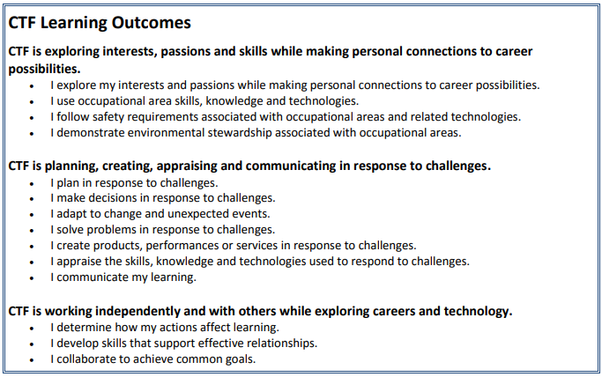
The aim for 3D Printing 7/9 CTF is to hit on the following competencies:
- I explore my interests and passions while making personal connections to career possibilities.
- I use occupational area skills, knowledge and technologies.
- I follow safety requirements associated with occupational areas and related tech.
- I plan in response to challenges.
- I make decisions in response to challenges.
- I adapt to change and unexpected events.
- I solve problems in response to challenges.
- I create products, performances or services in response to challenges.
3D Printing is an emergent field. In recent years its technology has become more and more affordable opening it up to new uses in manufacturing, medicine, and art to name a few. Computer Assisted Design has gone hand in hand with this new tech, CAD’s applications have even further applications in the future, especially within the industries of manufacturing, automotives and agriculture. Where CAD files are used to run machinery like plasma cutters, water cutters, auto parts manuals, and Global Positioning Systems.
Because of the above reasons, it is good to explore the basics of CAD programming. To do this 3D Printing will use a CAD program called TinkerCAD, to model various projects. Several of these projects will be printed using the 3D printers to bring to reality the students creations.

Below is a list of CAD projects that will be completed in class:

- Translating Household objects to Virtual Space
- Scaling buildings down to a printable model size
- Playgrounds
- 3d Snowflakes
- Design a Wallet tool
- Creating an object in Lego form
- Modeling a room in Virtual space

Class Expectations
- Be attentive, and focused on assignment or film
- Come to class prepared with a pencil, and workbook
- Clean up after yourself
- Keep the volume down when working upon assignments

A NOTE ON CTF ASSESSMENT PRACTICES:
The assessment plan supports the understanding that not all students learn the same way and at the same pace. The assessment practices serve a number of purposes, including:
- assess student achievement of learning outcomes
- provide behaviour descriptors
- personalize assessment
- differentiate instruction
- plan effective learning activities
- determine a student’s background knowledge and skills
- identify student strengths
- determine a student’s next learning steps

Grade | Description
Excellent | Exemplary performance of outcome(s); evidence shows in-depth understanding and independent work habits.
Proficient | Skilled performance of outcome(s); evidence shows solid understanding and occasionally guided work habits.
Satisfactory | Acceptable performance of outcome(s); evidence shows generally accurate understanding and guided work habits.
Limited | Partial performance of outcomes; evidence shows inaccurate understanding and ongoing support is needed during work.
Insufficient | Insufficient evidence to show the student has an acceptable performance of the outcome(s). The work must be improved and resubmitted.

.

