Fitness - CTF 6/7

Alberta Education has outlined 14 competency focused learning outcomes for CTF courses as listed below (which has been pulled directly from the Alberta Education website).

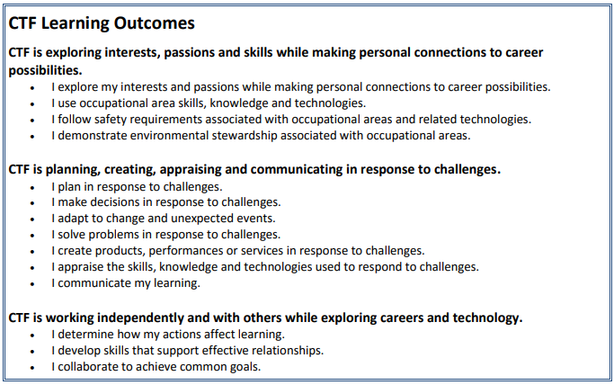

The plan for Fitness CTF is to hit a number of these competencies; specifically

- I explore my interests and passions while making personal connections to career possibilities.
- I use occupational area skills, knowledge and technologies.
- I follow safety requirements associated with occupational areas and related technologies.
- I adapt to change and unexpected events
- I create products, performances or services in response to challenges.
- I determine how my actions affect learning. I develop skills that support effective relationships. I collaborate to achieve common goals

The goal of this class is to work on various fitness and athletic pursuits in an attempt to improve personal fitness and knowledge of exercise and health. We will be exploring calisthenics, plyometrics, cardiovascular activity, stretching/flexibility, body weight exercises, a few weighted activities, basic nutrition and group fitness classes. Students will be assessed on effort, participation, preparation and development of form/technique. We will be doing a good deal of circuit training, as well as establishing a baseline level of fitness we will aim to improve upon. Student are expected to come to class changed and ready to sweat. We will be collaborating in a team setting; learning about skills necessary to thrive in the field of fitness, developing competency with specific fitness apparatus, discussing careers in fitness and running a student led exercise class.

Below is a list of the activities we will be doing in class (acknowledging that some additional activities may be incorporated).

- Calisthenics (push ups, chin ups, sit ups, planks, lunges, wall sits, burpees, dips)
- Plyometrics (box jumps, standing long jumps, fast feet, jump lunges, jump squats, lateral jumps, ladder runs)
- Functional Fitness (Tire flips, roller wheels, pull ups, medicine ball toss, weighted carries)
- Cardio (distance run, sprint sets, boxer skips)
- Stretching/Flexibility (group stretch, resistance band stretch, yoga, isometric stretches)
- Free Weights (bench press, dumbbell curls, shoulder press, tricep extensions)
- Abs (planks, flipper kicks, roll outs, v-sits, bicycle crunches, walking planks, oblique twists, russian twists)
- Potential other workouts (foam rollers, speed bags, grip strengtheners, aerobics)
- Nutrition (smoothie making, discussion of macronutrients, discovering foods that are deceptively unhealthy)

If any students have health concerns or limitations; please inform me ASAP, the goal is to get fit and have fun in a safe and injury free environment.

