Art 6/7 CTF

Alberta Education has outlined 14 competency focused learning outcomes for CTF courses as listed below (which has been pulled directly from the Alberta Education website).
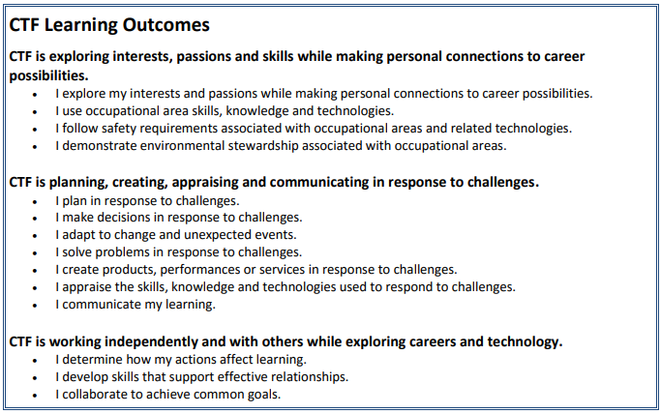

The aim for Art 6/7 CTF is to hit on the following competencies:
- I explore my interests and passions while making personal connections to career possibilities.
- I use occupational area skills, knowledge and technologies.
- I plan in response to challenges.
- I make decisions in response to challenges.
- I adapt to change and unexpected events.
- I solve problems in response to challenges.
- I create products, performances or services in response to challenges.

Art 6/7 CTF will be an exploration of various styles and to introduce students to some artistic techniques. As a class we will explore 6 artistic concepts of style and technique which are listed below. After a topic is introduced, students will work upon projects connected to the technique.
The goal of this CTF is to find creative projects that inspire students and allow them to express themselves while doing their best to incorporate techniques or inspiration discussed in class.

Below is a list of styles & techniques that will be discussed in class:

- Colour Theory
- Line and Shape
- Re-creation
- Stippling/Hatching/Cross-Hatching
- Sculpture
- Artistic careers

Class Expectations
- Be working on a self-selected or assigned project
- Come to class prepared with a pencil, and art book
- Incorporate each of the concepts discussed in at least one piece of work
- Clean up after yourself
- Keep the volume down
- Run all projects by me and show me final works
- Be creative, art is about self-expression

A NOTE ON CTF ASSESSMENT PRACTICES:
The assessment plan supports the understanding that not all students learn the same way and at the same pace. The assessment practices serve a number of purposes, including:
- assess student achievement of learning outcomes
- provide behaviour descriptors
- personalize assessment
- differentiate instruction
- plan effective learning activities
- determine a student’s background knowledge and skills
- identify student strengths
- determine a student’s next learning steps

Grade | Description
Excellent | Exemplary performance of outcome(s); evidence shows in-depth understanding and independent work habits.
Proficient | Skilled performance of outcome(s); evidence shows solid understanding and occasionally guided work habits.
Satisfactory | Acceptable performance of outcome(s); evidence shows generally accurate understanding and guided work habits.
Limited | Partial performance of outcomes; evidence shows inaccurate understanding and ongoing support is needed during work.
Insufficient | Insufficient evidence to show the student has an acceptable performance of the outcome(s). The work must be improved and resubmitted.

