Film Critic 8/9 CTF

Alberta Education has outlined 14 competency focused learning outcomes for CTF courses as listed below (which has been pulled directly from the Alberta Education website).
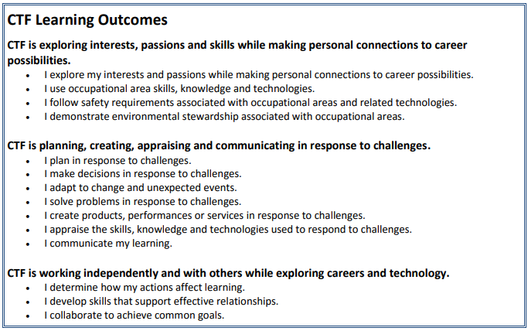

The aim for Film Critic 8/9 CTF is to hit on the following competencies:
- I explore my interests and passions while making personal connections to career possibilities.
- I use occupational area skills, knowledge and technologies.
- I plan in response to challenges.
- I make decisions in response to challenges.
- I adapt to change and unexpected events.
- I solve problems in response to challenges.
- I create products, performances or services in response to challenges.

Film Critic 8/9 is an exploration of filmography and the messages that can be found within popular media. As a culture we find ourselves constantly bombarded by media, which always has some form of message embedded within it. Since we find ourselves surrounded by this, weather it is a fast food ad or “Fake News,” we must be prepared to understand the messages that are being told to us everyday. The topics and skills that students will explore within Film Critic can be applied to such diverse media as music, social media, movies, television, and advertising. In this class we will learn filmography techniques, and how they are used to manipulate emotion, and the class will then apply this knowledge by watching 4 films with various themes. Upon watching a film there will be an assignment based upon each film and theme.
Below is a list of examples of filmography techniques that will be discussed in class:

- Dolly Shots
- Cuts
- Fades
- Dutch Angles
- Cinematography

Below is a list of the movies and themes that will be explored in class:

- Back to the Future- Narrative Storytelling
- Black Panther - Cinematography
- Spirited Away - Animation, and storyboarding
- O Brother Where art Thou? - Adaptation of other media to film

Class Expectations
- Be attentive, and focused on assignment or film
- Come to class prepared with a pencil, and film notes, workbook
- Clean up after yourself
- Keep the volume down when working upon assignments

A NOTE ON CTF ASSESSMENT PRACTICES:
The assessment plan supports the understanding that not all students learn the same way and at the same pace. The assessment practices serve a number of purposes, including:
- assess student achievement of learning outcomes
- provide behaviour descriptors
- personalize assessment
- differentiate instruction
- plan effective learning activities
- determine a student’s background knowledge and skills
- identify student strengths
- determine a student’s next learning steps

Grade | Description
Excellent | Exemplary performance of outcome(s); evidence shows in-depth understanding and independent work habits.
Proficient | Skilled performance of outcome(s); evidence shows solid understanding and occasionally guided work habits.
Satisfactory | Acceptable performance of outcome(s); evidence shows generally accurate understanding and guided work habits.
Limited | Partial performance of outcomes; evidence shows inaccurate understanding and ongoing support is needed during work.
Insufficient | Insufficient evidence to show the student has an acceptable performance of the outcome(s). The work must be improved and resubmitted.

.

