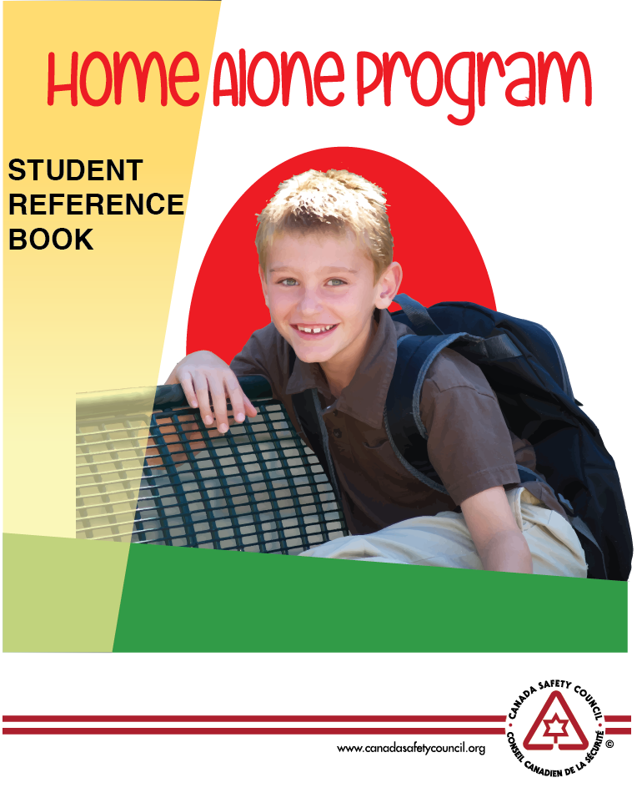

**Coming to Clyde!**

**Sponsored By:**

**WESTLOCK & DISTRICT**

**FCSS**

Pre-registration and payment is required.

To register and pay fees, call or visit the school office:

- 780-348-5341

Please advise if there are any allergy concerns when registering.

**Deadline to register: January 26**

Friday, January 28, 2022

9:00 am - 12:00 pm

Eleanor Hall School

Fee: $10

Age: Students grades 4-6

Please bring your own snacks.