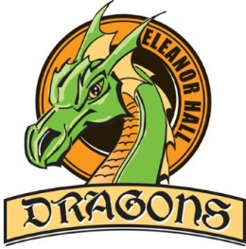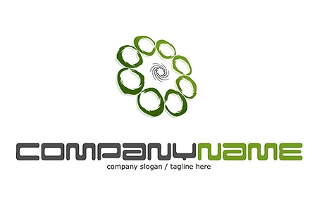

Please indicate your preference in order from 1-2 (1 - top choice to 2 - least favorite choice.)

*Missing submissions will be slotted into remaining CTF classes.*

|  |  |
| --- | --- |
| **Preference**  **(1-2)** | **6/7 CTF Challenge Quad 2** |
|  | Lego Robotics– Mr. Perreault  In this option, using Lego, students will begin this class by investigating simple machines, and computer programming. From this point the class will use their knowledge and creativity to build and program robots to solve a variety of tasks and missions. After this the class will take the wheel and will design an obstacle course of their own for their robots to complete. |
|  | Chaos Art – Mr. Gezmish  In this option, we will be creating a wide range of art. As many of the projects will be from the mind of Mr.G; It will be unique and a bit chaotic. Each student must bring their own creativity as this option will be a blast. |

You can refer to the school website for a description of each course and a link to the CTF outcomes.

<http://www.eleanorhallschool.ca/programs-clubs/ctf-career-technology-foundations/>



**Submit your CTF Registration Form to Mrs. Hnatiuk** ***no later than Thursday, Nov. 3, 2022***

*Missing submissions will be slotted into remaining CTF classes.*

**Student Name: ________________________________       Grade: __________**

**Signed______________________________________ Dated _______________**

(Parent/Guardian Signature)

**PO Box 70, 5402 – 50 St.**

**Clyde, AB T0G 0P0**

**780.348.5341**

**780.348.5713 (F)**

**www.eleanorhallschool.ca**

***The Eleanor Hall School vision is to provide a safe and caring learning environment that fosters the growth of academic development through creative and critical thinking skills for every student.***