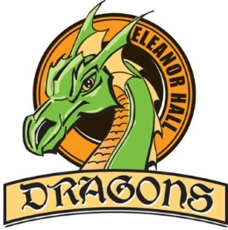

Please indicate your preference in order from 1-2 (1 - top choice to 2 - least favorite choice.)

*Missing submissions will be slotted into remaining CTF classes.*

|  |  |
| --- | --- |
| **Preference**  **(1-2)** | **8/9 CTF Challenge Quad 3** |
|  | Chess– Mr. Perreault  In this option, students (will learn how to) play Chess. Chess is a game of strategy, problem solving, game theory and patience. These skills transfer into other facets of their individual academics, allowing them to improve their approach and their ability to solve difficult problems. This option is for all levels of players. |
|  | Art – Mrs. Wasieczko  In this option, we will learn about the Indigenous Group of Seven. The Indigenous Group of Seven was one of the first independently organized, self-managed Indigenous artists’ collectives and cultural advocacy groups in Canada. Students will research each of the seven artists that formed the group, learning about their backgrounds and artistic styles. Students will see how each artist used the elements of art to create their artworks. We will then spend time recreating art pieces, of student choice, from the members of the group. |

You can refer to the school website for a description of each course and a link to the CTF outcomes.

<http://www.eleanorhallschool.ca/programs-clubs/ctf-career-technology-foundations/>



**Submit your CTF Registration Form to Mrs. Hnatiuk** ***no later than Thursday, Jan. 26, 2023***

*Missing submissions will be slotted into remaining CTF classes.*

**Student Name: ________________________________       Grade: ________**

**Signed:______________________________________ Dated ______________**

(Parent/Guardian Signature)

**PO Box 70, 5402 – 50 St.**

**Clyde, AB T0G 0P0**

**780.348.5341**

**780.348.5713 (F)**

**www.eleanorhallschool.ca**

***The Eleanor Hall School vision is to provide a safe and caring learning environment that fosters the growth of academic development through creative and critical thinking skills for every student.***